EXPLORATORY DATA ANALYSIS (EDA)
Job Acceptance Prediction System
Dataset: HR Job Placement Dataset
Total records analyzed: 50,000
Total columns: 26
Target variable: status — Placed / Not Placed

QUESTION 1: INTERVIEW ASSESSMENT SCORES VS. PLACEMENT
1. Introduction
Assessment scores are important indicators of a candidate’s technical knowledge, reasoning ability, and communication skills. Employers may consider these factors when evaluating whether a candidate is suitable for a particular position.
The dataset contains three assessment-related variables: technical_score, aptitude_score, and communication_score. Since there is no separate column named interview_score, these three variables are analyzed individually. A combined assessment score was also calculated by taking the average of the three scores for each candidate.
The purpose of this analysis is to examine whether candidates with higher assessment scores have different placement outcomes from candidates with lower scores.
2. Visualization
Recommended visualizations:
- Bar chart comparing the average technical, aptitude, and communication scores for Placed and Not Placed candidates.
- Histogram comparing the distribution of combined assessment scores across the two placement groups.
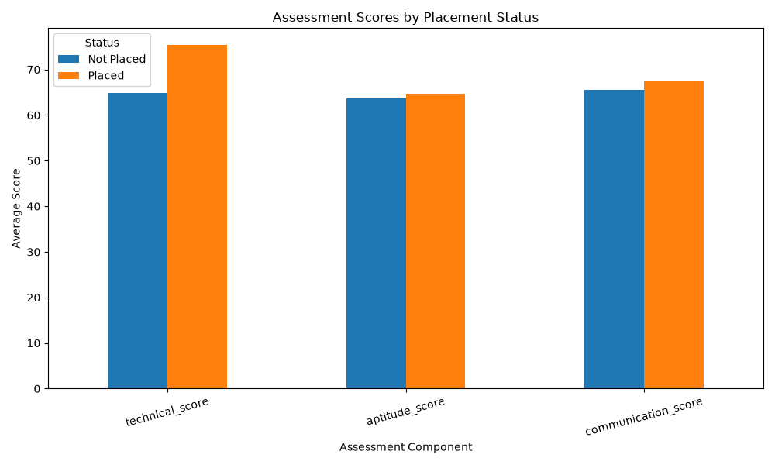
Figure 1: Average assessment scores by placement status.
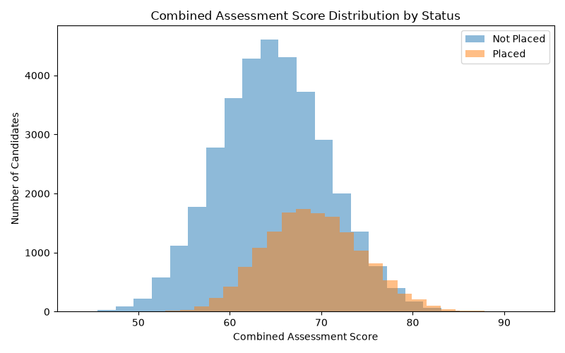
Figure 2: Combined assessment score distribution by placement status.
3. Problem Statement
The main problem is to determine whether assessment performance is associated with placement outcomes.
The analysis focuses on the following questions:
- Do placed candidates have higher average technical scores?
- Are aptitude and communication scores also different between the two groups?
- Does the combined assessment score provide a useful summary of overall assessment performance?
These comparisons can help identify assessment variables that may be useful in a placement prediction model.
4. Analysis
The average scores calculated from the dataset are shown below.
Assessment variable | Not Placed | Placed
Technical score | 64.88 | 75.30
Aptitude score | 63.74 | 64.59
Communication score | 65.46 | 67.57
Combined assessment score | 64.69 | 69.15
The most noticeable difference is in the technical score. Placed candidates have an average technical score of 75.30, compared with 64.88 among candidates who were not placed. This difference of 10.42 points suggests that technical assessment performance is associated with placement outcomes in this dataset.
The average aptitude score differs only slightly between the groups: 64.59 for placed candidates and 63.74 for candidates who were not placed. Communication scores show a somewhat larger difference, with averages of 67.57 and 65.46, respectively.
The combined assessment score is also higher among placed candidates, at 69.15 compared with 64.69. However, this combined score is a calculated feature, not an original dataset column or a verified official interview score.
Conclusion
Among the three assessment variables, technical score shows the largest difference between the placement groups. The combined assessment score also shows a difference that may be useful for further investigation.
These results demonstrate an association, not proof that higher assessment scores directly cause placement. The model should evaluate these variables alongside other candidate characteristics.

QUESTION 2: SKILLS MATCH PERCENTAGE VS. PLACEMENT
PAGE 3 OF 12
1. Introduction
Skills match percentage represents the degree to which a candidate’s skills align with the requirements of a job role. A stronger match may indicate that the candidate possesses more of the skills expected by the employer.
In this dataset, skills_match_percentage ranges from 45 to 100, with an average of 73.94. The analysis groups candidates into skills-match intervals and calculates the placement rate for each group.
The objective is to understand whether placement outcomes vary across different levels of skills alignment.
2. Visualization
Recommended visualization: Bar chart showing placement rate by skills-match group.
Figure 3: Skills match percentage vs. placement rate.
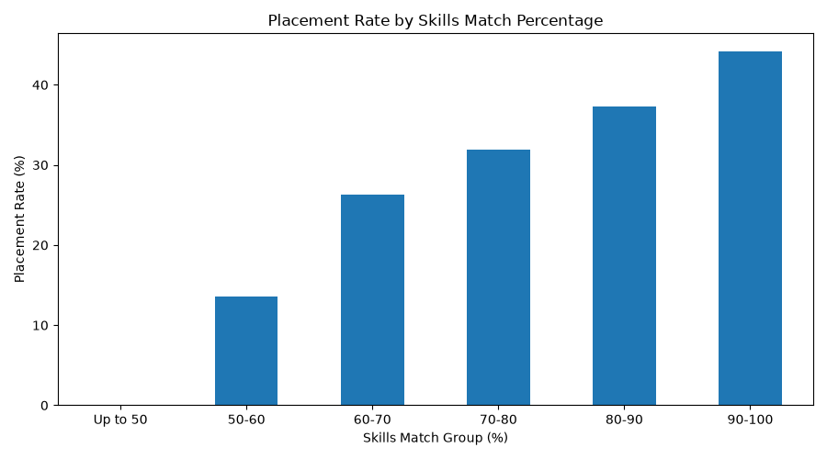
Use the following results in the chart:
Skills match group | Candidates | Placement rate
Up to 50 | 1,173 | 0.00%
50–60 | 5,032 | 13.63%
60–70 | 12,217 | 26.26%
70–80 | 16,138 | 31.96%
80–90 | 10,871 | 37.33%
90–100 | 4,569 | 44.21%
The chart should display the skills-match groups on the horizontal axis and placement rate (%) on the vertical axis. Data labels can be added to make the differences easier to understand.
3. Problem Statement
The problem is to determine whether candidates whose skills more closely match job requirements have higher placement rates.
The analysis investigates whether placement rates increase as skills-match percentage increases and identifies the skills-match groups with the highest and lowest observed placement rates.
4. Analysis
The results show an overall increasing pattern between skills match percentage and placement rate.
Candidates in the 50–60 group have a placement rate of 13.63%. This rises to 26.26% for the 60–70 group and 31.96% for the 70–80 group. Candidates in the 80–90 group have a placement rate of 37.33%, while the 90–100 group records the highest rate at 44.21%.
The group with skills-match values up to 50 has 1,173 candidates and a reported placement rate of 0%. This is a notable observation in the dataset and should be verified against the underlying records and the way the groups were created before making a broad conclusion about all candidates with low skills match.
The difference between the 50–60 group and the 90–100 group is 30.58 percentage points. This indicates that placement outcomes differ substantially across these two skills-match groups.
Conclusion
Skills match percentage appears to be an important variable for further placement analysis. Candidates in higher skills-match groups have higher observed placement rates in this dataset.
However, this relationship does not establish causation. Other factors, such as technical assessment performance, relevant experience, job-role match, and competition level, may also contribute to placement outcomes. The predictive model should evaluate the contribution of skills match alongside these variables.

QUESTION 3: COMPANY TIER VS. PLACEMENT
1. Introduction
Company tier is a categorical variable that divides the records into Tier 1, Tier 2, and Tier 3 companies. Comparing placement rates across these categories can help determine whether the company-tier classification is associated with differences in candidate placement outcomes.
The dataset contains 19,305 candidates in Tier 1, 18,483 in Tier 2, and 12,212 in Tier 3. These groups provide a basis for comparing placement rates.
2. Visualization
Recommended visualization: Bar chart showing placement rate for each company tier.
Figure 4: Company tier vs. placement rate.
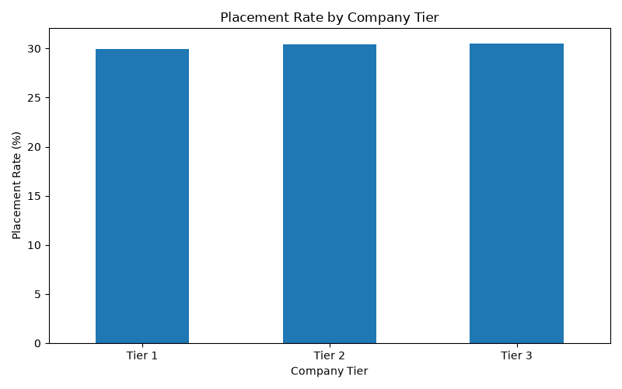Use these values:
Company tier | Candidates | Placed candidates | Placement rate
Tier 1 | 19,305 | 5,779 | 29.94%
Tier 2 | 18,483 | 5,622 | 30.42%
Tier 3 | 12,212 | 3,729 | 30.54%
The chart should show the three company tiers on the horizontal axis and placement rate (%) on the vertical axis. Since the rates are close, use a clearly labeled axis and data labels to make the small differences visible.
3. Problem Statement
The problem is to determine whether company tier is associated with different placement rates.
Specifically, the analysis compares the placement rate of Tier 1 companies with those of Tier 2 and Tier 3 companies. It also checks whether the observed differences are large enough to suggest a meaningful pattern.
4. Analysis
The observed placement rates are 29.94% for Tier 1, 30.42% for Tier 2, and 30.54% for Tier 3.
Tier 3 has the highest placement rate in this dataset, at 30.54%, while Tier 1 has the lowest, at 29.94%. The difference between the highest and lowest rates is only 0.60 percentage points.
This is a relatively small difference. Therefore, the results do not show a strong descriptive relationship between the company-tier category and placement rate in this dataset.
The number of candidates differs across the tiers, but all three groups contain a substantial number of records. This makes the comparison useful for exploratory analysis. Nevertheless, the placement rates alone do not explain why a candidate was placed or not placed.
The category labels should also be interpreted according to the dataset’s definitions. The analysis does not establish how company tiers were assigned or whether they represent company size, reputation, compensation, or another classification.
Conclusion
Company tier shows only small differences in observed placement rates. Tier 3 records the highest rate, but the gap between the three categories is limited.
Company tier can remain a candidate feature for the prediction model, but its predictive value should be tested rather than assumed. Its importance may become clearer when considered together with assessment scores, experience, skills match, and other variables.

QUESTION 4: YEARS OF EXPERIENCE VS. PLACEMENT
1. Introduction
Work experience may influence how well a candidate meets the requirements of a job. Candidates with more experience may have developed practical knowledge, job-related skills, and familiarity with workplace responsibilities.
The dataset includes years_of_experience, with values ranging from zero to five years. The average experience is 1.49 years. This analysis compares the number of candidates and placement rate at each experience level.
2. Visualization
Recommended visualization: Line chart showing placement rate by years of experience.
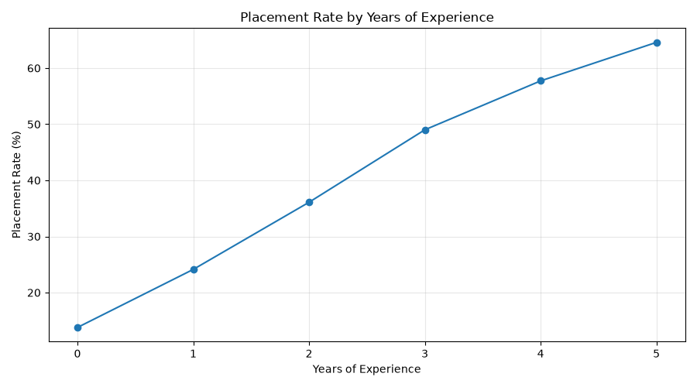Figure 5: Years of experience vs. placement rate.
Years of experience | Candidates | Placed candidates | Placement rate
0 | 14,952 | 2,061 | 13.78%
1 | 13,508 | 3,259 | 24.13%
2 | 9,966 | 3,597 | 36.09%
3 | 6,538 | 3,204 | 49.01%
4 | 3,548 | 2,048 | 57.72%
5 | 1,488 | 961 | 64.58%
The horizontal axis should show years of experience, while the vertical axis should show placement rate (%). A line chart makes the overall trend easier to identify.
3. Problem Statement
The problem is to determine whether placement rates vary with the number of years of experience.
The analysis examines whether placement rates increase as experience rises and whether the pattern is consistent across the six experience groups.
4. Analysis
The results show a clear increasing pattern in placement rates across the experience groups.
Candidates with zero years of experience have a placement rate of 13.78%. This increases to 24.13% for candidates with one year of experience and 36.09% for those with two years.
The placement rate reaches 49.01% at three years of experience, 57.72% at four years, and 64.58% at five years. The five-year group therefore has the highest observed placement rate, while the zero-year group has the lowest.
The difference between these groups is 50.80 percentage points. This is one of the clearest descriptive patterns identified in the EDA.
The number of candidates also decreases as experience increases: there are 14,952 candidates with no experience compared with 1,488 candidates with five years. The rate for the five-year group is therefore based on a smaller group than the rate for candidates with zero years of experience.
Although the pattern is strong, the analysis cannot prove that experience alone causes a higher placement rate. Experience may be related to other factors, such as previous salary, relevant experience, technical performance, and job-role match.
Conclusion
Years of experience shows a strong positive association with placement rate in this dataset. The increasing pattern suggests that experience may be a useful feature for the prediction model.
The next stage should test whether experience remains predictive when other candidate characteristics are considered together. The model should also be evaluated on unseen data to establish how reliably it predicts placement outcomes.

QUESTION 5: COMPETITION LEVEL VS. PLACEMENT
1. Introduction
Competition level is a categorical feature that classifies records into Low, Medium, and High competition. Competition may be relevant to placement outcomes because the availability of suitable positions and the number of competing candidates can affect the likelihood of a candidate being placed.
In this dataset, 20,841 candidates are classified under Low competition, 19,114 under Medium competition, and 10,045 under High competition.
The purpose of this analysis is to compare the placement rate across these three categories.
2. Visualization
Recommended visualization: Bar chart showing placement rate by competition level.
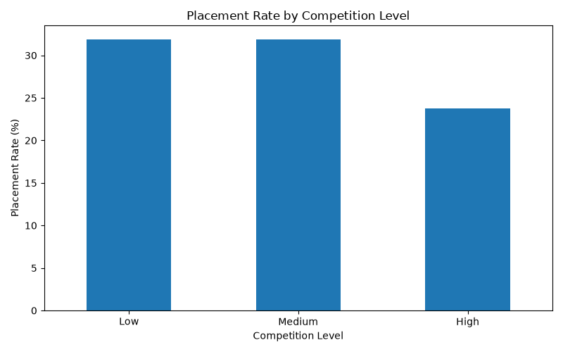Figure 6: Competition level vs. placement rate.
Use these values:
Competition level | Candidates | Placed candidates | Placement rate
Low | 20,841 | 6,643 | 31.87%
Medium | 19,114 | 6,098 | 31.90%
High | 10,045 | 2,389 | 23.78%
Place the competition categories on the horizontal axis and placement rate (%) on the vertical axis. Include percentage labels above each bar.
3. Problem Statement
The problem is to determine whether placement outcomes differ across the recorded competition levels.
The analysis focuses on whether High competition is associated with a lower placement rate than Low and Medium competition, and whether the rates for Low and Medium competition are meaningfully different.
[INSERT PAGE BREAK]
PAGE 10 OF 12
4. Analysis
The placement rates for Low and Medium competition are almost identical. Low competition has a placement rate of 31.87%, while Medium competition has a rate of 31.90%. The difference is only 0.03 percentage points.
High competition, however, has a lower placement rate of 23.78%. This is 8.09 percentage points below the Low competition rate and 8.12 percentage points below the Medium competition rate.
This pattern suggests that the High competition category is associated with less favorable placement outcomes in the dataset. In contrast, the difference between Low and Medium competition is negligible.
The High competition group contains 10,045 candidates, which is smaller than either the Low or Medium group but still large enough to support a useful descriptive comparison.
The results should be interpreted carefully because the dataset does not, by itself, establish how competition levels were measured or assigned. Other variables may also differ between the groups and may contribute to the observed placement rates.
Conclusion
High competition is associated with a lower observed placement rate than Low and Medium competition. This makes competition level a useful variable to investigate in the prediction stage.
However, the relationship should not be interpreted as proof that competition alone determines placement. The predictive model should consider this feature alongside candidate skills, experience, assessment scores, and other relevant variables.

QUESTION 6: CORRELATION ANALYSIS AMONG NUMERICAL FEATURES
1. Introduction
Correlation analysis is used to measure the strength and direction of the linear relationship between pairs of numerical variables. It helps identify variables that may move together and highlights possible redundancy among features.
The dataset contains 14 numerical features, including age, academic percentages, assessment scores, skills match, certifications, experience, salary expectations, notice period, and employment gap.
The analysis uses a correlation matrix to compare these numerical variables. A correlation coefficient generally ranges from -1 to +1. Values near +1 indicate a strong positive linear relationship, values near -1 indicate a strong negative linear relationship, and values near zero indicate a weak linear relationship.
2. Visualization
Recommended visualization: Correlation heatmap of the 14 numerical features.
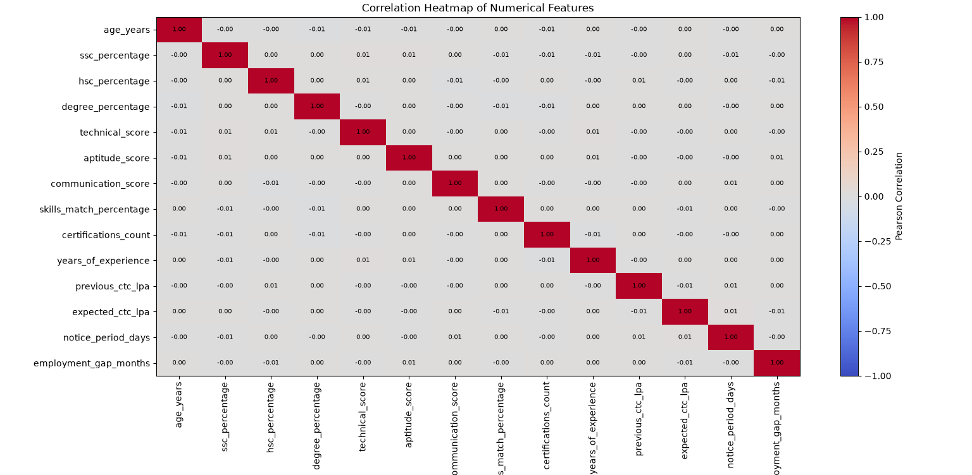Figure 7: Correlation matrix of numerical variables.
The heatmap should display the numerical features along both axes. Each cell represents the correlation coefficient for a pair of variables. The diagonal contains values of 1.00 because each variable is perfectly correlated with itself.
Use a readable color scale and, if possible, display the correlation coefficients inside the cells. This will help distinguish stronger relationships from weaker ones.
3. Problem Statement
The problem is to identify whether any numerical features have strong linear relationships with one another.
The analysis aims to determine whether some variables may contain overlapping information and whether there are relationships worth investigating before model development.
The correlation matrix contains numerical predictors; it does not include the target variable status in the displayed analysis.
4. Analysis
The displayed correlation matrix shows many off-diagonal coefficients close to zero. This suggests that several pairs of numerical features have weak linear relationships in the dataset. The complete heatmap should be reviewed to identify any individual pairs with stronger positive or negative correlations.
A low Pearson correlation does not mean that two variables have no relationship. They may have a nonlinear relationship, or their relationship with placement may depend on other features. Similarly, correlation does not establish causation.
The matrix can help identify possible redundancy between numerical predictors, but it should not be used as the only criterion for removing features. Each variable should also be considered in terms of its business meaning and predictive value.
For example, technical score, aptitude score, and communication score measure different assessment dimensions. Even if their correlations are weak, each may provide distinct information. Likewise, previous CTC and expected CTC should be interpreted in the context of candidate experience and salary expectations.
Since the target variable is categorical, its relationship with the numerical features should be evaluated separately using suitable classification analysis and model evaluation methods. The correlation heatmap alone cannot determine which variables are most important for placement prediction.
Conclusion
Correlation analysis provides an overview of the linear relationships among numerical predictors and helps inform the next stage of model development.
The displayed results suggest that many pairs have weak linear correlations, but the complete heatmap should be examined before drawing conclusions about individual feature pairs. Feature selection should be guided by data quality, domain relevance, and performance during model evaluation rather than correlation alone.

OVERALL EDA SUMMARY
The exploratory analysis was conducted on 50,000 records and 26 columns after data cleaning. The cleaned dataset contained no missing values or exact duplicate rows at the time of analysis. The target distribution was 69.74% Not Placed and 30.26% Placed.
The six analyses identified several useful patterns. Technical assessment scores were higher on average among placed candidates. Placement rates increased across higher skills-match groups and higher experience levels. Company tier showed only small differences in placement rates, while the High competition group had a lower placement rate than the Low and Medium groups. Correlation analysis provided an initial view of the relationships among numerical features.
These findings are exploratory and do not establish causation. The next stage is feature preparation and classification modeling, followed by evaluation on unseen data using measures such as precision, recall, F1-score, a confusion matrix, and ROC-AUC.
Important terminology note: The dataset’s target column is status, with values Placed and Not Placed. Unless the dataset documentation confirms that these values represent acceptance or rejection of a job offer, the analysis should be described as placement prediction rather than confirmed job acceptance prediction.

